How will we pay for it?

As we embark on our “Time to Build” Stewardship campaign, we have prayerfully set a goal of reaching $100,000 in donations and pledges.
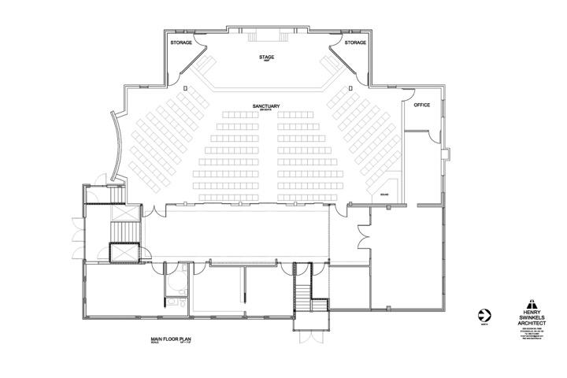
Once we reach that target, we would ask the congregation for the green light to begin construction, hopefully in the spring of 2017.

The remaining costs would be added to our existing mortgage which is presently about $140,000.

What does the Bible say about financial stewardship?

The Bible has a great deal to say about our attitude to money and material possessions. In the Sermon on the Mount. Jesus gave us some important guidelines on how to Invest our money in a way that will have a lasting impact for the kingdom of God.

- Invest wisely

“Do not store up for yourselves treasures on earth, where moth and rust destroy, and where thieves break in and steal. But store up for yourselves treasures in heaven, where moth and rust do not destroy, and where thieves do not break in and steal. For where your treasure is, there your heart will be also.” (Matthew 6:19-21)

Jesus calls us to realize that many of our financial investments have their risk and will fade with time. The wisest investment is in heaven and the work of God here on earth.

- Invest generously

“The eye is the lamp of the body. If your eyes are good, your whole body will be full of light. But if your eyes are bad, your whole body will be full of darkness. If then the light within you is darkness, how great is that darkness!” (Matthew 6:22-23)
Proposed new sanctuary plan

Seating increases from approx 160 max. to 250
More comfortable seats, movable chairs
Contemporary, functional seating layout

Bad attitudes, such as a grudging and ungenerous spirit, distort our view of life and other people. In 2 Corinthians 9:7, Paul writes that we are to give, “not reluctantly or under compulsion, for God loves a cheerful giver. “
- Invest authoritatively

“No one can serve two masters. Either he will hate the one and love the other, or he will be devoted to the one and despise the other. You cannot serve both God and Money.” (Matthew 6:24)

Money can be a good servant, but it is a terrible master. Jesus warns us that we must take authority over our money and use it as God guides, or it will control us.

- Invest in faith.

“Therefore I tell you, do not worry about your life, what you will eat or drink; or about your body, what you will wear. . . . For the pagans run after all these things, and your heavenly Father knows that you need them. But seek first his kingdom and his righteousness, and all these things will be given to you as well. Therefore do not worry about tomorrow, for tomorrow will worry about itself. Each day has enough trouble of its own.” (Matthew 6:25-34)

Jesus encourages us to rise above a lifestyle of worry and fear, and live wisely but freely, by faith investing in the work of the Kingdom of God.

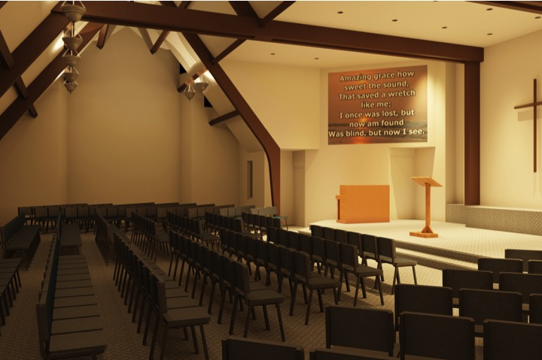
In order for us to bring these plans to reality, we will all need a united vision, a great measure of faith, and a willingness to give time and financial resources. If God is in this, then we believe He will provide all that is needed when we step out in faith and obedience to His plans. Please prayerfully consider how you can respond “not with equal gifts, but with equal sacrifice.”

We believe that this project will be a great time of spiritual growth for all of us: an opportunity to grow in our personal walk with the Lord, to grow in unity as we work as a team together, to grow in our faith as we see God do more than we can even imagine right now.

Why do this now?

We believe it is important to have a church facility that is attractive and welcoming to newcomers, and provides adequate space for the future growth of our church family.

While we are grateful for our present church building, we have recognized that there are significant shortcomings which are hindering our potential for future ministry and growth. Even if we did not embark on this building project, we would soon have to invest significant resources just to make the renovations and repairs necessary to keep our existing building in good working order.

We are convinced that this building renovation will have a powerful and positive impact on our ability to meet our church’s ability to grow and move ahead into the future.

1. What will we gain from a renovation/expansion of the church sanctuary?

- A modern, more functional, versatile, and comfortable worship space, with seating for approximately 250 people (compared to about 160 presently)

2. What will it cost?

- Our architect, Henry Swinkels, has given us an estimate of approximately $200,000 plus about $25,000 for new chairs, furnishings and equipment

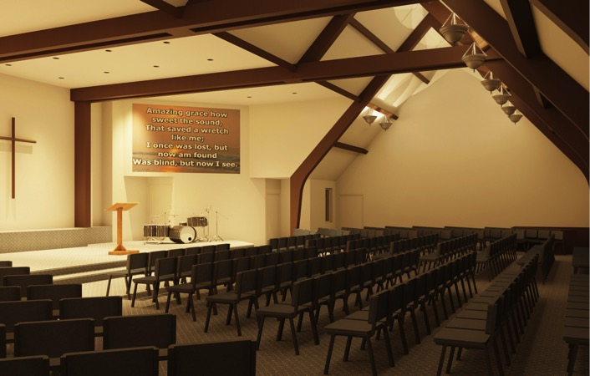

First Baptist Church
165 Bertie Street Fort Erie ON L2A 1Y9
(905) 871 6577 forteriefirstbaptistchurch.org

First Baptist Church

Fort Erie

“A Time to Build”

Stewardship Campaign

October – November 2016

“There is a time for everything,
and a season for every activity under heaven:
a time to be born and a time to die,
a time to plant and a time to uproot…
a time to tear down and a time to build”

Ecclesiastes 3:1-3

Building for the Future!

“On this rock I will build my church…” Matthew 16:18

What a faithful and powerful God we serve!

Almost 75 years ago, God laid it on the heart of a small group of people here in Fort Erie to plant a church which would serve as a faithful witness to the surrounding community in the generations to come. Now today we see how God has continued to build his church here at First Baptist Church. While the journey has not always been easy, and there are many challenges still ahead of us, we believe that the Lord wants us to faithfully continue to pursue the vision of a strong, evangelical witness here in our community in the years ahead.

A church is much more than bricks and mortar. Our church is made up of the people of God: called by the Father, redeemed by the Son, moving and growing in the power of the Holy Spirit.

But bricks and mortar are important in order for us to have a place to gather together as the people of God, in order to bear witness to Christ in our community. We are grateful to God for the building He has given us, which is heavily used every week for regular times of worship, children’s and youth ministry, Bible study, prayer and fellowship.

Ten years ago, our church had the vision to carry out a major expansion of our facilities, which has proven to be an incredible blessing to our church. But now we believe the time has come to also upgrade and expand our church sanctuary. The proposed building project would not only increase our seating capacity by about 50%, but it would give us a modern attractive space that would allow everyone to participate more fully in our worship services. We are excited about the way in which these improvements will enhance the ministry of our church in the years to come.

Our church exists today because of the vision and commitment of faithful generations who have gone before us. It is now time for our generation to do its part for the generations that will follow us. We know that many challenges still lie ahead. In order to see the vision become reality, it will require commitment and sacrifice from all of us. Our faith will be stretched!

What shall I do?

CAREFULLY READ all the information in this brochure.

PRAYERFULLY SEEK God's direction as you join with the rest of the church family and get involved in this exciting project. Remember that the amount you give is a commitment over and above your regular offering. It is a matter between you and God. There is no gift too small or too large.

COMPLETE THE COMMITMENT CARD once you have determined what you will trust God to provide towards this endeavour.

Bring it to church and hand it in on
Commitment Sunday November 13
Also please fill out the duplicate card below
and keep it as a record of your commitment.

-------------------------------------YOUR COPY --------------------------------------
“A Time to Build”
COMMITMENT CARD

Because I believe in the future ministry of our church,
I make my commitment as follows:

I would like to give a one time gift of $___________________
I would like to make an ongoing pledge of :
$__________ weekly for a 3-year total of $_____________ or
$__________ monthly for a 3-year total of $____________ or
$__________ yearly for a 3-year total of $ _____________.

Name________________________________ Signature: ______________________________
NOTE: Your commitment may be revised should your circumstances make this necessary.

“Remember this: Whoever sows sparingly will also reap sparingly, and
whoever sows generously will also reap generously.” (2 Cor 9:6)

